Practice Assignment #1
Classes

- RoboRace
Create a program that has the starting situation of Fig.1 and the ending position of Fig. 2. Alternate the actions of the two robots so that they arrive at their destination at approximately the same time.
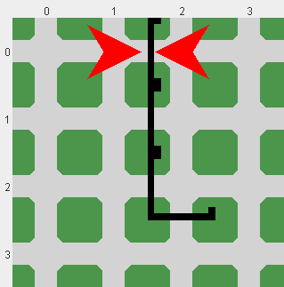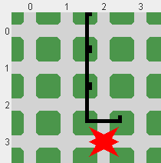

Fig.1 Fig. 2

- RobotMover
Create a program that will make a Robot move a Thing as shown below:

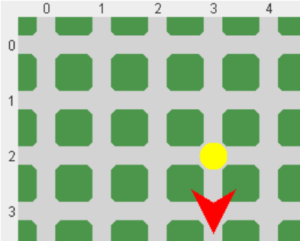
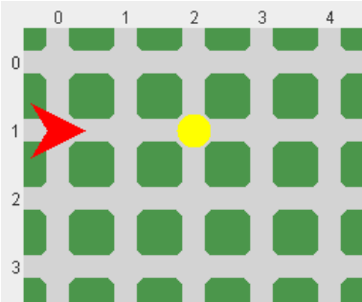

Fig. 3 Fig. 4

- MountainClimber
The wall sections in Fig. 5 represent a mountain (north is up). Write a program that makes the robot pick up a flag (a thing), climbs the mountain, and plants the flag at the top, descending down the other side. The robot must follow the face of the mountain as closely as possible.

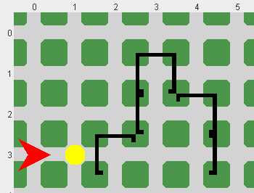

Fig. 5

- Explore the Robot environment by creating your own scenario.

